Ignasi Arranz, Bertrand Fournier, Nigel P. Lester, Brian J. Shuter, and Pedro R. Peres-Neto. Species compositions mediate biomass conservation: the case of lake fish communities. Ecology.

Appendix S7. Examining the spatial autocorrelation for the regression models

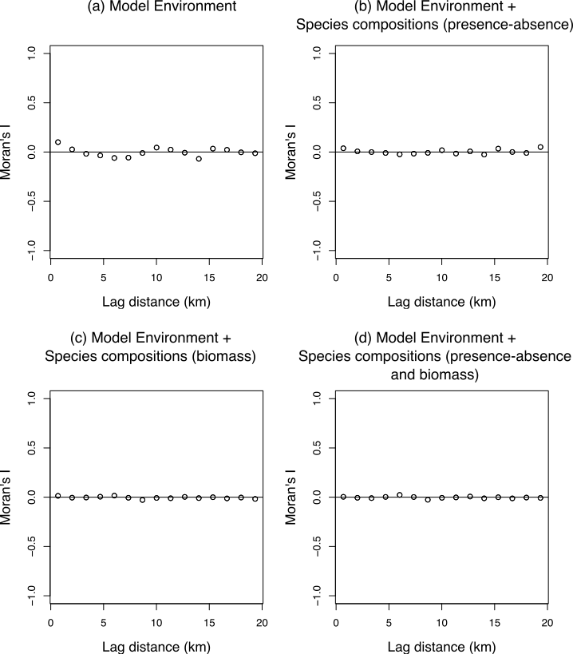

**Figure S1.** Spatial correlograms of model residuals in each of the models.